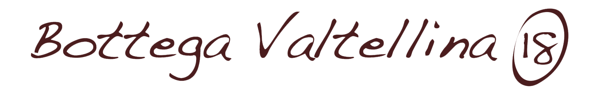

**Beverage**

* Water € 1,00
* Small beer € 3,00
* Medium beer € 5,00
* Glass of wine € 4,00
* House wine:

¼ € 3.00

½ € 6,00

* Soft dinks € 3,00
* Coffee € 1,00
* Coffee decaffeinated/ginseng/orzo € 1,20
* Corrected coffee € 1,50

**Dish of the day € 18,00**

Grilled sea bass with roasted potetoes

**First plate € 7,00**

* Sedani with woodcutter (cream, tomato, ham and mushrooms) (1/7)
* Farfalle with gurnard fillet*, tomato, caper flowers and mint (1/4)
* Pasta with turnip greens (1/4)

**Second plate € 9,50** (GRILLED VEGETABLES WITH SIDE REPLACEMENT + €3.00)

- Roast veal served with baked potatoes (1/9)

- Warm Ligurian octopus* (potatoes, pesto and green beans*) (4/7/8/14)

- Tomino wrapped in bacon with honey and chips* (7)

- Small bag of burrata with turkey breast (7)

- Grilled Angus tartare with baked potatoes

**Single dish of land € 12,00**

Sedani with woodcutter (cream, tomato, ham and mushrooms) (1/7)

&

Roast veal served with baked potatoes (1/9)

**Single dish seafood € 12,00**

Farfalle with gurnard fillet*, tomato, caper flowers and mint (1/4)

&

Warm Ligurian octopus* (potatoes, pesto and green beans*) (4/7/8/14)